* Index.html

|  |
| --- |
| <!DOCTYPE html>  <html lang="en">  <head>  <meta charset="UTF-8">  <meta name="viewport" content="width=device-width, initial-scale=1.0">  <title>Movie Highlights</title>  <link rel="stylesheet" href="style.css">  </head>  <body>  <header>  <h1>Movie Highlights</h1>  </header>  <main>  <div class="content">  <h2>The Shawshank Redemption</h2>  <img src="asset/the shawshank redemption.jpg" alt="The Shawshank Redemption">  <p>A story of hope and friendship.</p>  </div>  <div class="content">  <h2>Inception</h2>  <img src="asset/inception.jpg" alt="Inception">  <p>A mind-bending thriller that will leave you questioning reality.</p>  </div>  <div class="content">  <h2>The Godfather</h2>  <img src="asset/The_godfather.jpg" alt="The Godfather">  <p>The classic tale of family and power.</p>  </div>  <div class="content">  <h2>The Dark Knight</h2>  <img src="asset/The_dark_knight.jpg" alt="The Dark Knight">  <p>Batman faces his greatest challenge yet.</p>  </div>  <div class="content">  <h2>Forrest Gump</h2>  <img src="asset/Forrest Gump.jpg" alt="Forrest Gump">  <p>The extraordinary life of an ordinary man.</p>  </div>  <div class="content">  <h2>Fight Club</h2>  <img src="asset/Fight club.jpg" alt="Fight Club">  <p>An underground fight club evolves into something much more.</p>  </div>  <div class="content">  <h2>The Matrix</h2>  <img src="asset/the matrix.jpg" alt="The Matrix">  <p>A hacker discovers the true nature of reality.</p>  </div>  </main>  <footer>  <p>&copy; 2024 Movie Highlights</p>  </footer>  </body>  </html> |

* Style.css

|  |
| --- |
| body {  font-family: Arial, sans-serif;  margin: 0;  padding: 0;  box-sizing: border-box;  }  header,  footer {  background-color: #333;  color: white;  text-align: center;  padding: 20px 0;  }  h1 {  margin: 0;  }  main {  display: grid;  grid-template-columns: 1fr;  gap: 10px;  padding: 20px;  }  .content {  padding: 20px;  text-align: center;  width: 200px;  height: 330px;  background-color: #f4f4f4;  padding: 10px;  border: 1px solid #ddd;  box-sizing: border-box;  }  .content img {  max-width: 100%;  height: auto;  border-radius: 8px;  width: 100%;  height: 165px;  object-fit: contain;  border-radius: 20px;  }  .content h2 {  font-weight: 100;  }  @media (min-width: 600px) {  main {  grid-template-columns: repeat(2, 1fr);  }  }  @media (min-width: 900px) {  main {  grid-template-columns: repeat(4, 1fr);  }  } |

* Output:

(On Desktop)

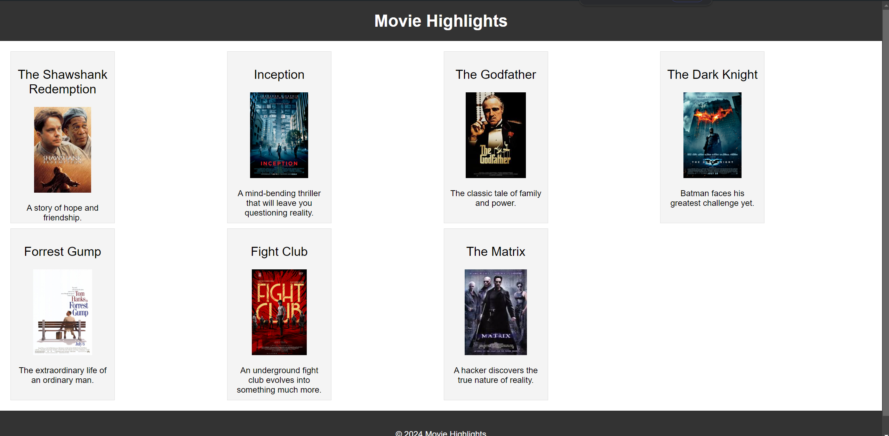

(On mobile)

 